Experimental Report
Course name | Digital Image Processing
Student number | 2011561103 | Name | MD MUSTAFIZUR RAHMAN
Major | CST | Class | 20LC
Experiment Date | 22-10-11
Experimental content | For example (Delete the red word when submitting the report)  Experiment 1 :Preliminary Exercises with MATLAB Image Processing Toolboxes
1．Purpose and tasks of the experiment

The main purpose & task of this experiment is to understand the basic use of the software ‘MATLAB’. And also, the master reading of image data & information in MATLAB language. Moreover, the master conversion of image type in the MATLAB software to know the MATLAB Language.

2. Experimental steps and results

Describe the basic steps and main codes of the experiment and give the experimental results with pictures.
(Delete the red word when submitting the report)

Steps: 1) At first, we need to install the MATLAB software in our computer.
2) Create a custom or self-built folder path for the work.
3) Drop the image file through which we’re going to test the experiment.
4) Created a new m-file in MATLAB software and write the code in the editor panel.
5) Now, to read the image file and image file info we used imread, imfinfo command to observe the image and finally we understand the digital image in MATLAB processing.

Result:

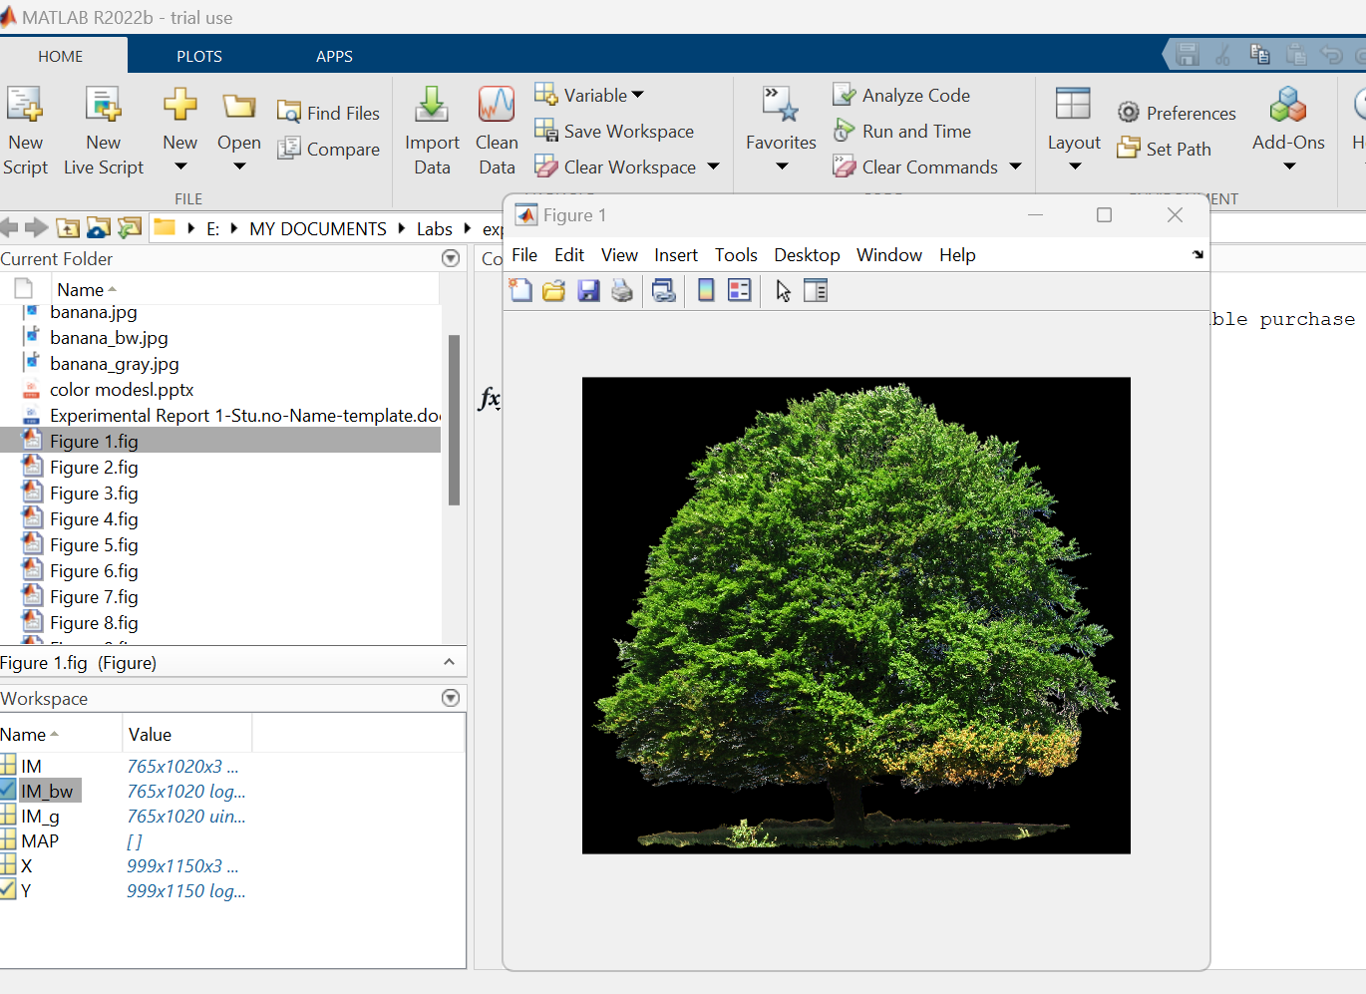

6) When we performed and display then we mutually understand the transformation between true color image, thumbnail, grayscale and binary image respectively for the flowers.tif showed below. We use imshow(rgb2ind(I,map)) for RGB to thumbnail, imshow(rgb2gray(I)) for RGB to grayscale and for RGB to Binary image we use imshow(im2bw(I))command. And here is

Result:

t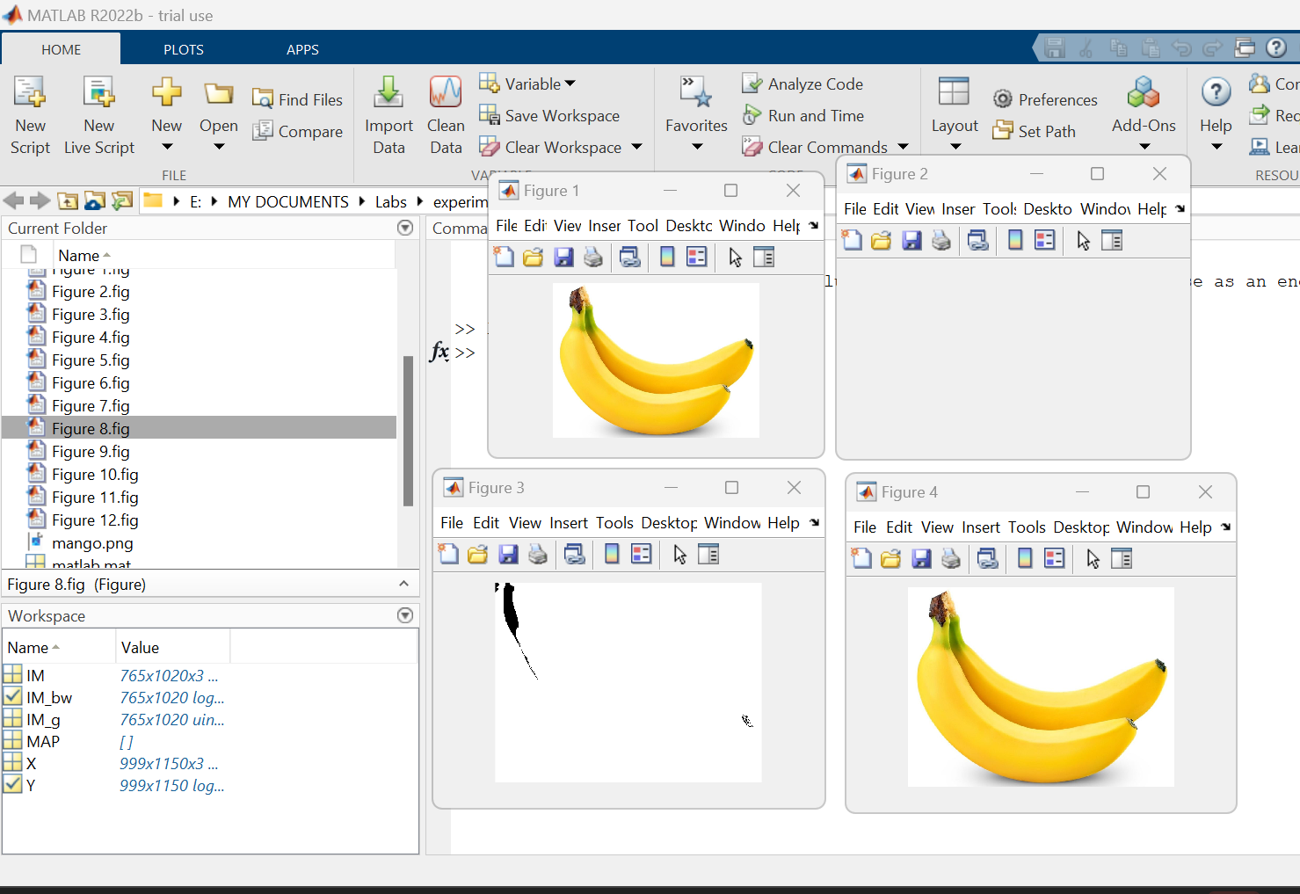he result

7) And also, to understand the mutual conversion of true color, RGB, YIQ, HSV and YcbCr image we used another image named as lenacolor.jpg. We use rgb2ntsc(I)for RGB to YIQ, imshow(rgb2hsv(I))for RGB to HSV and for RGB to YCbCr we use rgb2ycbcr command. And here is the result.

Result

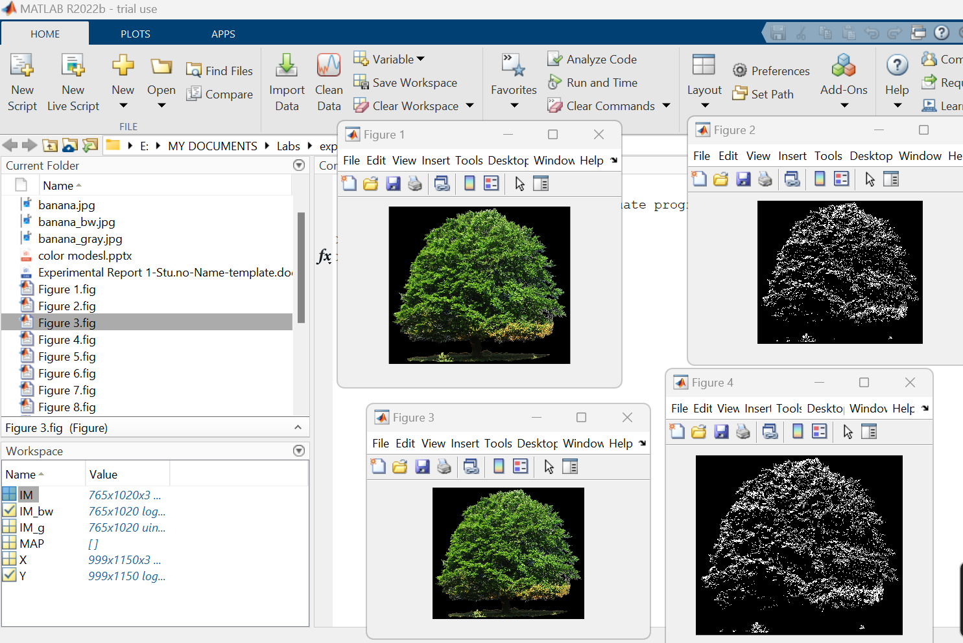

3. Answer the following question?
What is the basis of conversion between images, why can achieve mutual conversion.

Answer: Image Processing or conversion between images, is the art of conducting different methods, actions, or transformations on an image, either by enhancing it, manipulating it, or changing its content that will suit our need. Image Processing or conversion is the core of operations are in a sense, are different mathematical equations performed on the image itself wherein the image will be changed according to the mathematical function that we have defined. Since we will treat the Image that it can be transformed and enhanced using different MATLAB language techniques and matrices.

So now we were able to show different basic image processing techniques that deal with the different conversion of the images. We are able to also show the difference between each color channel, binarize, grayscale, and other conversion technique. And this is what we can achieve mutual conversion.

4. Experimental experience

It means your feelings and your harvest

For me this is an outstanding experiment. I’m learning to use a new software name MATLAB for the first time. And it was and unbelievable experience for me to change the color of any image in different color at once through a coding.Now I can convert an image
use rgb2ntsc(I)for RGB to YIQ, imshow(rgb2hsv(I))for RGB to HSV and for RGB to YCbCr we use rgb2ycbcr comman. Love to do the work and looking forward for more outstanding experiment through this course.

